Experiment 1.1.5 - Student Pass Or Fail Status
PRN:25070521167

A) Algorithm :
- Start
- Read marks (m)
- If m ≥ 40 then print "Pass"
- Else print "Fail"
- Stop

B) Flowchart :
Flowchart diagram:
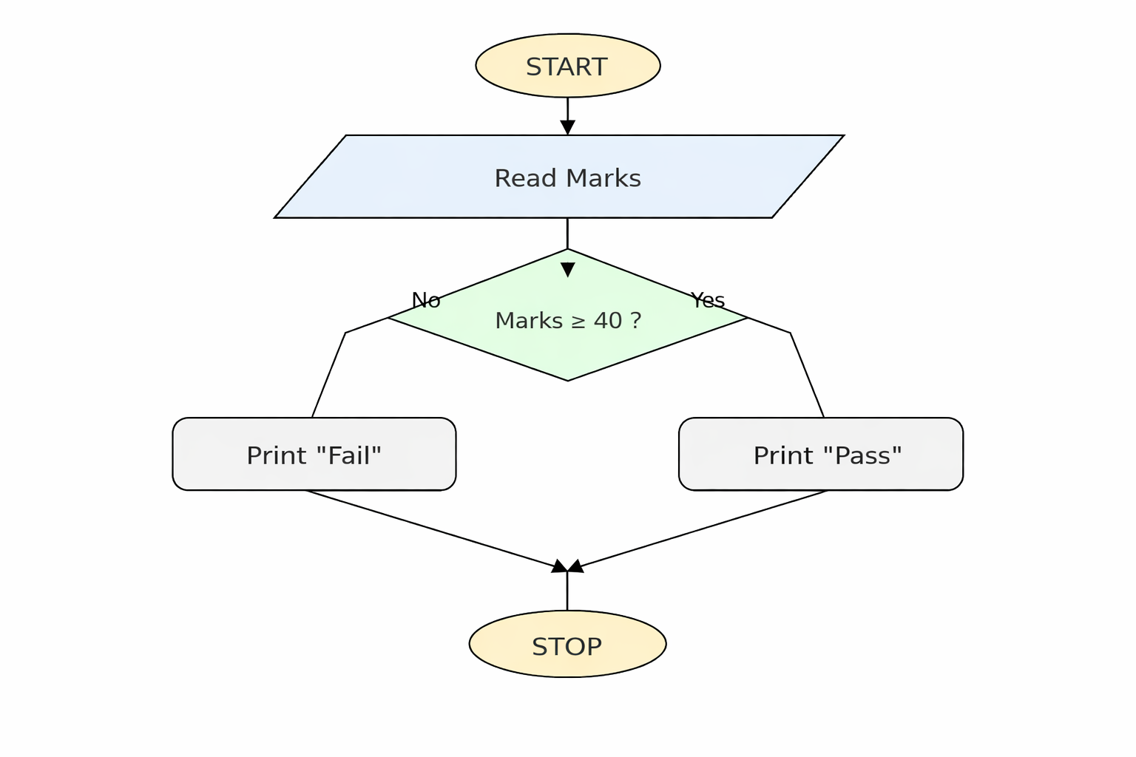

C) Python Code
marks = int(input())
if marks >= 40:
print("Pass")
else:
print("Fail")
